Electronics Documentation

1. Electronics Block Diagram
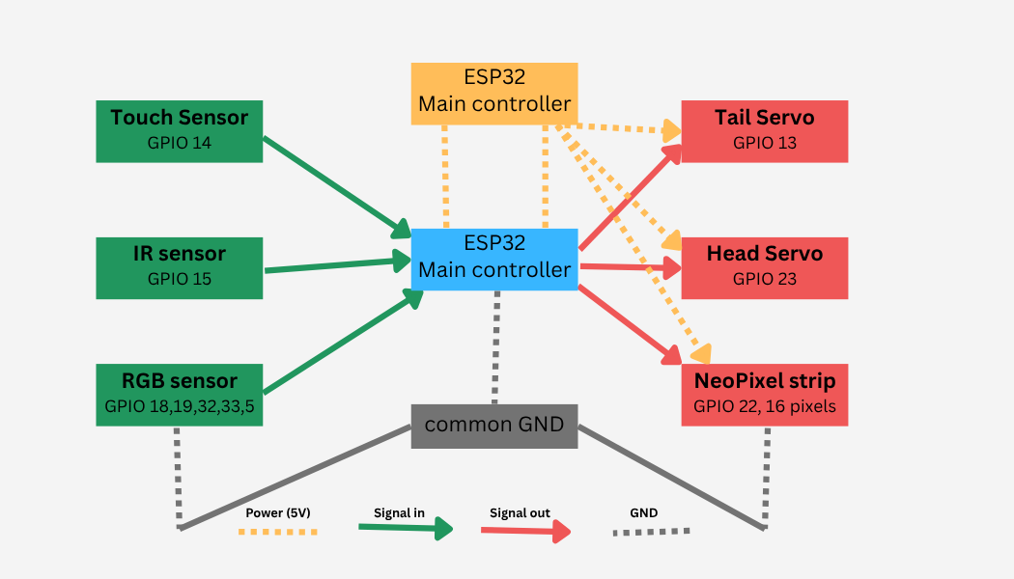

2. Components Table
Component | Qty | Purpose | Justification
ESP32 Microcontroller | 1 | Controller : Main brain; reads all sensors and controls outputs | Enough GPIO for 3 sensors + 3 outputs. Supports MicroPython for easier development.
TCS3200 RGB Sensor | 1 | Sensor: Detects color of object in front of it | Accurately detects color using frequency output; affordable and easy to use
NeoPixel LED Strip | 1 | Output: Displays detected color on chameleon’s neck | Individually addressable LEDs with bright output and simple one-wire control
Touch Sensor | 1 | Sensor: Detects when someone shakes the chameleon’s hand | Uses built-in capacitive touch; reliable and requires no extra components
IR Sensor | 1 | Sensor: Detects when someone approaches the chameleon | Simple and effective short-range proximity detection with quick response
Servo Motor (Tail) | 1 | Output : Moves tail when handshake is detected | Allows smooth and precise movement using PWM control
Servo Motor (Head) | 1 | Output: Turns head away when someone comes near | Provides controlled and repeatable rotation; same type simplifies design
Power Module (5V) | 1 | Power: Supplies stable 5V to servos and NeoPixel | Delivers stable power and supports higher current for motors and LEDs

